Appendix A: Electrical Circuit Primer©

- An optional lab to teach the basics of electrical circuits and the use of meters

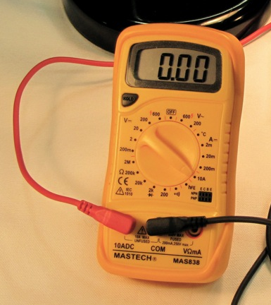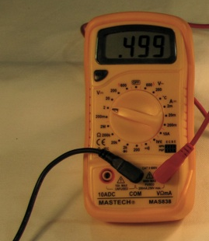
Multimeter as Amp meter Multimeter as Volt meter

Materials:

Multimeters 2

The following are NOT SUPPLIED IN PHOTOVOLTAIC KITS
1.5V battery
Miniature 6V Light Bulb
DCV Power Supply (capable of 2 amps)
5 Watt resistors 2 of different values (i.e. 4 and 8 Ohms or other available values)

Overview: A series of tests are made, first with a light bulb and then with resisters. The goal of these tests is to gain experience with use of the multimeters and learn basic information about selected solar technologies.
To understand how Photovoltaic systems work, we need to know about electricity, electrical circuits and the devices used to measure electric current and voltage.

GOALS:
- To understand the concepts of Voltage and Current,
- To learn how to connect Current and Voltage meters to a circuit
- An introduction to concepts of circuit Resistance and Power.

Part I: Voltage (V) Current (I), Resistance (R) and meters,

Part A: A circuit is connected at your work table. It consists of a battery, a light bulb connected to two meters. Connect the voltage supply to the light bulb by closing the switch and record the meter readings in volts and amperes. Voltage is a measurement of electrical pressure that can make electrical charges move. Amperes is a measurement of how many charges move through the wires and light bulb in a given time. 1 ampere is approximately 1*10¹⁹ electrons moving past a point in 1 second.

Electrical pressure = volts
Current = amps

Notice two important factors with the connections. The Voltage is measured with the wires coming from the meter being connected across the source. The current I is measured by having the moving charges go through the meter. A Current meter acts just like a piece of wire!! This is important to understand when connecting meters in circuits.

1.) A Voltmeter is connected directly across the component that you want to measure

2) An Ammeter is connected into a circuit like a piece of wire so current can go through it.

Part B Take a small jumper wire and, just for a moment, connect it across the terminals to the Ammeter. What happens to the current and voltage readings? Does the light bulb go out?

Why? The current goes to zero because current flows like water, taking a path of least resistance. The wire is a path of least resistance so the current goes through the wire instead of the meter. The light bulb stayed lit because the current is still flowing through the bulb. The voltage reading stayed relatively the same. The circuit is not really altered since the ammeter is like a piece of wire.

Part C Take the small jumper wire and, just for a moment, connect it across the terminals of the battery. What happens to the current and voltage readings? Does the light bulb go out?

Why? The voltage and current both go to zero because again current flows like water, taking a path of least resistance. The wire is a path of least resistance so the current goes through the wire instead of the entire circuit! The light bulb goes out because the current is no longer still flowing through the bulb. The circuit is drastically altered. If you leave the wire connected across the battery, it will get hot!

Part II Voltage, Current and Ohm’s Law

Part A: Disconnect the leads from the battery and connect them to the Power Supply. Make sure the control knob is turned completely counter clockwise. Turn on the supply and adjust the knob for 4 different voltages and complete the table below. Rate the Bulb Output, as dim, bright, brightest.
Table A.1: Voltage and Brightness
Voltage (V) | Bulb Output

1V

3V

4V

What happens to the voltage if you turn the knob and make the light bulb dimmer? Explain how the voltage and bulb brightness are related. (Use your own words, but think of the voltage as an electrical pressure.) (Your words.)

Part B Disconnect the light bulb and replace it with one of the resistors located at your station. Write in the value of R in the space provided. Turn on the supply and adjust the knob for 4 different voltages and complete the table below.
R1 =
V=Voltage (Volts) | I=Current (Amperes) | R (Ohms) = V/I | Power=IV (Watts)

1V

2V

3V

4V

You can see that the voltage and current are related to each other. The higher the voltage, the higher the current will be. This relationship between voltage and current is called Ohm’s Law. V=IR

Repeat the measurements for the second resistor.
R2 =
V=Voltage (Volts) | I=Current (Amperes) | R (Ohms) = V/I | Power=IV (Watts)

1V

2V

3V

4V

The value R is called the resistance. Compare the currents with R1 to the currents with R2. For a given voltage, say 4V, how do the two currents compare?

Does your observation agree with what we would suspect by solving the Ohm’s Law equation for I, I=V/R?

Power is calculated by taking the product of the Voltage V times the Current I. P=IV. If we substitute IR for V we see that P is also equal to I²R. Complete the table by calculating P using both equations and comment how the Power especially relates to the current. (How much does the Power change when the current is doubled?)

Conclusion: What I hope you got out of this is:
- How to connect voltage and current meters. We will be doing a lot of that in the PV lab exercises.
- You are exposed to the idea of how Voltage, the electrical energy pressure, pushes charges through a circuit. The resistance is a characteristic of a device in the circuit that determines the amount of current that will flow. The Power is the required voltage and current needed to make the electrical circuit do what it is supposed to do, be it a toaster or a computer.

