PV Activity 5b Optional: Photovoltaic Cell Voltage Output vs. Lamp Distance©

- To investigate the dependence of the output Voltage of a photovoltaic (PV) cell on the distance between the PV cell and an incandescent lamp.

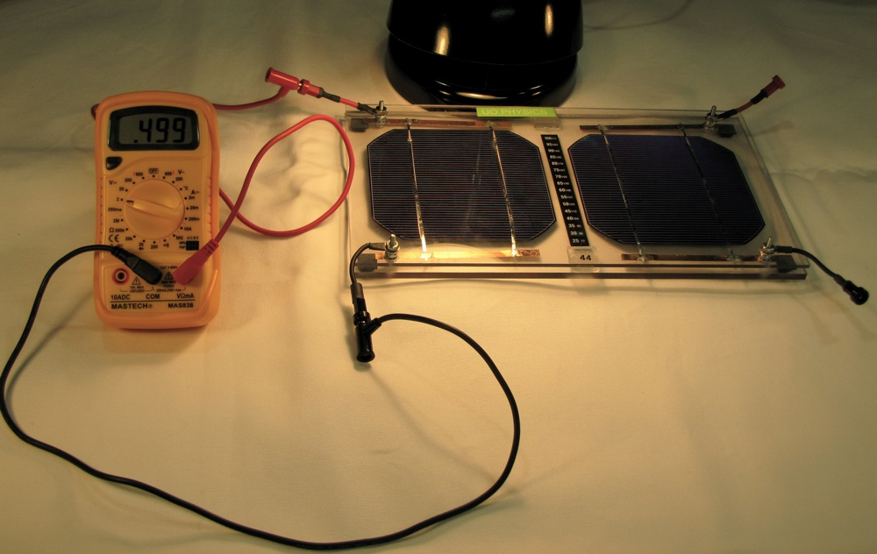
Volt meter measuring open circuit voltage for one cell
(Initially, the lamp should be as close to the PV cell as practical and still allow for an accurate measurement between the bulb and the module.)

MATERIALS
• PV Cell Module
• Electrical Leads
• DC voltmeter
• 1 Lamp

Overview: This experiment is an addendum to PV Activity 5, and measures the open circuit voltage as the distance between the lamp and the solar cell changes. A discussion of the principles involved in the experiment is given after the description of the experiments.
Open Circuit Voltage
- Connect one Soar Cell in the PV Module to the volt meter as shown in the Fig. B.1. The red connector is the + output of the cell. The + output connects to the VΩmA input on the meter. The negative black output of the cell connects to the COM input of the meter. Set the meter dial to the 2 VDC setting, that is the “2” setting on the left side of the dial. Place the desk lamp as close as you can to the PV cell, and measure the actual distance between the bulb and the cell and the open circuit voltage measured by the meter. Record these voltage measurements in Table B.1. (If your voltage reading is zero, check your connections and meter settings or ask an instructor for assistance.)
Fig. B.1: Connections for measuring open circuit voltage
- Vary the distance of the lamp to the cell by placing the lamp on blocks or books. Each time, record the distance (d) between the lamp and the bulb and the output voltage in Table B.1.
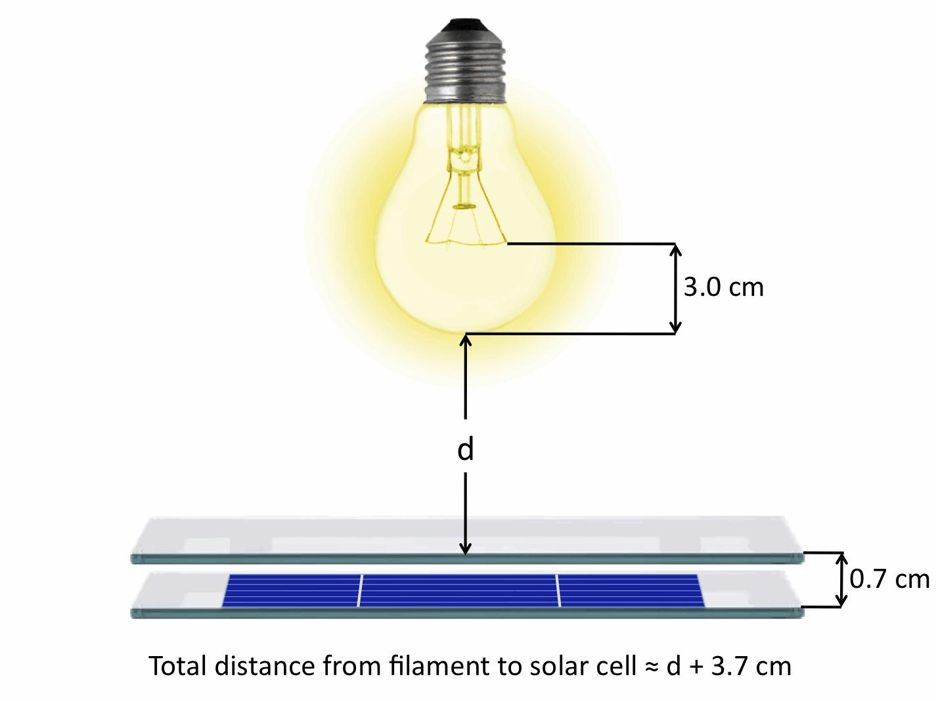
Fig B.2: Measuring distance between solar cell and light bulb filament.

Table B.1: Voltage and Distance
Distance between bulb surface and PV Module (cm) | ACTUAL DISTANCE  (Measured Distance +3.7cm) | Voltage (Volts)
What happens to the voltage when you double the distance between the lamp and the cell? Is the voltage half as much or is the relationship different than the relationship between short circuit current and the distance from the lamp?
Result discussion: The shape of the Power vs. Distance graph obtained in PV Activity 5 is a result of how light intensity from a point source diminishes over distance. The power falls as a 1/r² relation, because the number of photons striking the surface would decrease as a 1/r² relation.
The open circuit voltage output of the cell is mainly related to the intrinsic nature of the solar cell. Silicon based solar cells are created by bring silicon doped with atoms with one extra and one lacking valence electron together. At the interface of the two types of materials, an electric field is created when the extra valence electrons fill in the holes left around the atoms lacking one valence electron. The difference in the charges of the nucleus of the doping atoms creates an electric field that gives rise to the open circuit voltage. The open circuit voltage can be thought of as the field holding the electrons and the holes apart. This voltage changes with temperature and other factors.
The short circuit current is the maximum number of charges that can flow each second from the cell. The number of charges available IS DEPENDENT on the intensity of the light. Each flowing charge resulted from the interaction with a photon of light. The intensity of the light is directly related to the number of photons striking the solar cell. Solar cells are also dependent upon the wavelength of the light (see PV Activity 4), but in general, the more intense the light, the more photons strike the cell, the more current is available. You should have observed that the voltage also increases with intensity, with a maximum voltage in the range of 0.5V – 0.6V.
The sensitivity of the output current and power with light distance makes it essential to maintain the same light intensity for all future lab measurements. This criterion is met by keeping the distance between the bulb and PV module constant when comparing measurements, or keeping the angle of the PV module and sunlight constant, assuming the intensity of the sunlight is not varying.
Discussion:
- Write down your comments and what you learned or questions you have after completing Table B.1.

- Are your observations consistent with the discussion above?

- How do your observations confirm or conflict with the discussion about?

- How would you improve on the experiment?

