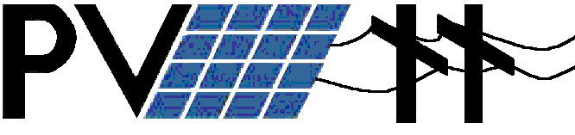
In Schools
November 21, 2000

PV Lesson Plan 1 – Solar Cells



Prepared for the Oregon Million Solar Roofs Coalition

By Frank Vignola – University of Oregon Solar Radiation Monitoring Lab
John Hocken – South Eugene High School
Gary Grace – South Eugene High School
Solar Cells Lesson Plan

Content: In this lesson, students are introduced to the basic physics and chemistry behind the operation of a solar cell. They will learn how a single crystal silicon cell accepts energy from light and turns it into electricity.

Objectives: Students will be able to answer basic questions about the process of turning light energy into electrical energy.

Student background: It is assumed that students are familiar with the electron-proton-neutron model of the atom and with the basic ideas of bond formation involving shared pairs of electrons. It is also assumed that they know about the idea of valence electrons. The notion that like charges repel and opposites attract is also assumed.

Methodology: Present the material in the handout “How Solar Cells Turn Sunlight into Electricity” (below) as appropriate for your situation. Provide ample time for discussion and questions, and for relating the material to your curriculum. The suggested questions could be used for homework, quizzes, etc.

How Solar Cells Turn Sunlight into Electricity

Solar cells are materials that turn sunlight into electricity. This effect was first recorded by E. Becquerel, in 1839. The first solid state device was recorded to show such an effect in 1877. However, it was in 1954 at Bell Labs when the solar electric effect was demonstrated in silicon that the idea of producing useable amounts of electricity from solar cells began.

The question is, how do solar cells produce electricity?

Two facts are important to the understanding of how solar cells work.

- First, sunlight is composed of photons of various energies.
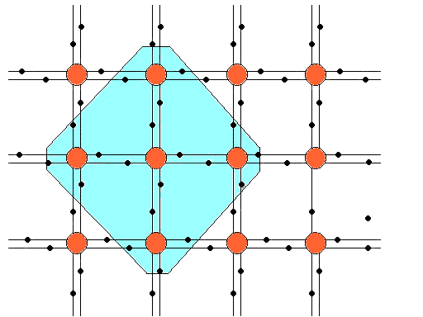
- Second, photons can interact with atoms, and if a photon has sufficient energy, it can break the bond between an electron and the atom.
Basic Silicon Crystal Unit
Incoming light
Light generated free electron
Light generated hole
Light of sufficient energy can dislodge a negative electron from its bond in the crystal, creating a positive hole (a bond missing an electron) and a free electron. These negative and positive charges, which move freely for a time about the crystal lattice, are the constituents of electricity.

The trick to making solar cells produce electricity is the ability to “collect” the electron once it has been separated from the atom. The resulting flow of electrons is called the photocurrent.

The example of solar cells made from single crystal silicon will be used to illustrate the general principles.

Silicon is an atom with four valence electrons. In single crystal silicon, each of the valence electrons forms a bond with a valence electron of a neighboring silicon atom. This electron to electron bond is very strong and in a perfect crystal there are no free valence electrons waiting to bond with another electron. Electrons bond in pairs when possible (lower energy state).

Pure single crystal silicon is a very poor conductor because all the valence electrons are bonded with their neighbors.

To collect the photocurrent, solar cells are constructed like a battery. This is done by taking two semiconductors of opposite charge and putting them together.

To make solar cell semiconductor material from silicon approximately 2x10¹⁶/cm³ acceptor atoms (atoms with three valence electrons such as boron) or approximately 10¹⁹/cm³ donor atoms (atoms with five valence electrons such as phosphorous) are substituted for the silicon atoms with four valence electrons.

When phosphorous is substituted for a silicon atom, four of the five valence electrons form strong bonds with the nearest silicon electrons and the remaining electron is very loosely bound by the slightly more positive charge of the nucleus of the phosphorous atom. However, this electron travels easily around the crystal lattice in the area of the phosphorous atom. Silicon that contains a large number of atoms with an extra valence electron is called n type silicon (n is for negative).

If a boron atom is substituted for a silicon atom, the three valence electrons form strong bonds with the nearest silicon electrons, but there is one silicon electron that is left looking for a partner to bond with. This missing electron that is being sought for bonding, is called a hole. Because the hole is a missing electron, it can be treated mathematically like the free electron when phosphorous is substituted, but it effectively has a positive charge (the absence of an negative electron). Silicon that contains a large number of atoms with one less valence electron is called p type silicon (p is for positive).

The process of substituting boron or phosphorous atoms for silicon atoms is called doping. This is often done by thermal diffusion.
When n- and p-type silicon come into contact, electrons move from the n-side to the p-side. This causes a positive charge to build on the n-side of the interface (or p-n junction) and a negative charge to form on the p-side.
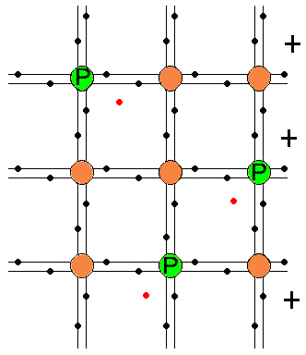
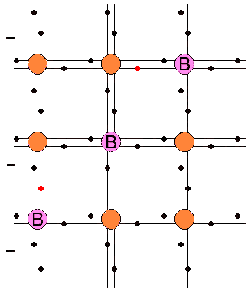
Junction forming
p - Side
n - Side
A solar battery is created when n and p type silicon are placed next to each other. The extra electrons from the phosphorous are attracted to the holes created by the doping of the silicon with boron. This occurs because binding of the electron pairs is much stronger than the electromagnetic attraction between the outer electrons and the nucleus of the atoms that is masked by the electrons that are surrounding each atom in the crystal structure.

Near the junction of the n and p type material, holes on the p-side are filled with the free electrons from the n-side forming strong, stable electron pair bonds. This results in a shift in charge that creates an electric field in the material. When the free valence electron from the n-side combines with the single bound valence electron on the p-side, the phosphorus atom is surrounded by one less electron than there are positive protons in the phosphorus nucleus. Similarly, the boron atom is surrounded by one more electron than there are positive protons in the boron nucleus. While this n-p ‘junction’ is only a few atoms thick, the resulting electric field creates a barrier that prevents additional crossover of holes from the p-side and electrons from the n-side. This electric field (resulting in an electromotive force, EMF, of approximately 0.5 volts) makes it possible to create the photocurrent when light breaks the electron-electron pair bond
+
+
+
+
+
_
_
_
_
_
+
_
n-Side p-Side
Boron
Phosphorous
Junction
The buildup of excess positive and negative charges on either side of the junction creates an electric field across the interface; the strength of this field depends on the amount of dopant in the silicon. At equilibrium, the electric field repels any additional crossover of holes from the p-side or electrons from the n-side.
Now when the photon enters the material and breaks apart an electron pair, a negative electron and a positive hole are created. If it weren’t for the electric field, the electron and the hole would attract and recombine. With the electric field, the negative electron goes one direction and the positive hole goes the other direction. This is the source of the electricity of a solar cell.
Junction
+
_
n-Side p-Side
Boron
Phosphorous
_
+
When sunlight striking a cell creates charge carriers (electrons and holes), the electric field pushes new electrons to one side of the junction and new holes to the other. This sorting-out process is what drives the charge carriers in an electric circuit.

The minimum energy that it takes to break up the electron-electron bond is called the band gap†. Photons with energy less than the band gap won’t separate the electron pairs. Photons with more energy than necessary to separate the electron pairs result in electrons and holes with more kinetic energy.

When solar cells get hot, the electrons and atoms are vibrating faster and the effectiveness of the electric field to separate the electrons and holes is diminished. The randomly directed kinetic energy becomes the dominant factor governing the motion of the electrons and holes. Typical loss in efficiency is about 0.1%/degree Celsius measured solar cell temperature. (A solar cell that is 16% efficient at 25º Celsius will be 9% efficient at 100º Celsius.)

[Figures based on slides from the National Renewable Energy Laboratory]

Further resources and follow up: There are numerous websites with information on this topic. The University of Oregon's Solar Radiation Monitoring Lab maintains a site at http://solardat.uoregon.edu/ that has solar data, information about solar monitoring, and lists and links to many other sites. A nice supplement to the teaching material above can be found by going to the U of O site and selecting the “PV Performance Calculator-NREL”. At that site select “How Photovoltaics Work” for materials of various interesting kinds.

Useful Web Sites:

http://www.eren.doe.gov/millionroofs/whatispv.html
http://www.sandia.gov/pv/training.htm
http://www.nrel.gov/ncpv/
http://www.fsec.ucf.edu/Ed/index.htm
http://www.nrel.gov/data/pix/searchpix.html
http://www.ascensiontech.com/RTD/ashlandrtd.html
http://www.ascensiontech.com/RTD/pge.html
http://www.ases.org/
http://www.seia.org/main.htm
For further reading:
The Solar Electric House by Steven J. Strong with William G. Scheller, Sustainability Press, Still River, Massachusetts 01467-0143, 1987.
From Space to Earth – The Story of Solar Electricity, John Perlin, aatec publications, Ann Arbor, MI 48107, 1999.

† The term band gap refers to the energy necessary to separate the electron pair. It can also be thought of as the energy necessary to make an electron in the valence band jump into the conduction band. The valence band is where the electrons are bonded and the conduction band is where the electrons are free to flow as a current. When the electron pairs are separated by a photon, any energy of the photon above the band gap energy goes into the kinetic energy of the electron.

