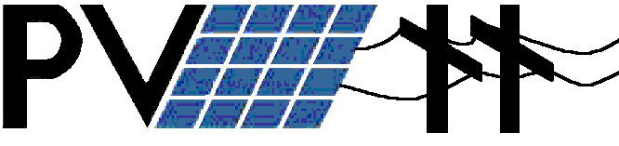
In Schools
November 21, 2000

PV Lesson Plan 2 – Solar Electric Arrays



Prepared for the Oregon Million Solar Roofs Coalition

By Frank Vignola – University of Oregon Solar Radiation Monitoring Lab
John Hocken – South Eugene High School
Gary Grace – South Eugene High School

Solar Electric Array Less Plan

Content: In this lesson, students are introduced to the components of a solar electric system and the concept of the photovoltaic IV curve. They will learn how modules are put together to generate the desired voltage and current, and how an inverter helps the system to operate efficiently.

Objectives: Students will be able to answer basic questions about how a solar electric system operates.

Student background: It is assumed that students are familiar with the fundamentals of current and voltage and the concept of batteries.

Methodology: Present the material in the handout “Grid tied solar electric system” (below) as appropriate for your situation. Provide ample time for discussion and questions, and for relating the material to your curriculum. The suggested questions could be used for homework, quizzes, etc.

Grid tied solar electric system
A solar cell is a semicondutor device designed to turn solar irradiance into electricity. (Solar irradiance is electromagnetic energy from the sun. Electromagnetic energy from other sources such as lamps can also be used by solar cells to generate electricity if the energy of the photons is high enough to break up the electron pairs.)
The voltage of the electric current from a single or multi-crystalline silicon solar cell is 0.5 volts. This results from the voltage across the N/P barrier layer of the solar cell.
The current or amperage of the solar cell is dependent on the number of electrons that are knocked into the conduction band. This current is proportional to the amount of solar radiation incident on the solar cell. The current from the solar cell can be increased by increasing the area of the solar cell or by increasing the amount of solar radiation incident on the solar cell.
Solar cells can be thought of as solar batteries. If solar cells are connected in series, then the current stays the same and the voltage increases.
(–)
(+)
(–)
(+)
(–)
(+)
Solar cells in series boost voltage

If solar cells are connected in parallel, the voltage stays the same, but the current increases.
(–)
(+)
(+)
(+)
(–)
(–)
Solar cells in parallel boost amperage

Solar cells are combined to form a ‘module’ to obtain the voltage and current (and therefore power) desired. For example, to form a 12-volt module, 24 solar cells have to be connected in series. A group of solar cells put together is often called a photovoltaic module.
Power is equal to current times voltage. The power rating of a photovoltaic module is typically quoted as the power output of the module when the incident solar radiation is 1000 watts/meter squared and the temperature is 25º C. This is a typical value of solar radiation around the middle of a clear summer day. A one-meter square module that is 15% efficient would therefore have an output of 150 Watts on a clear day near noon.
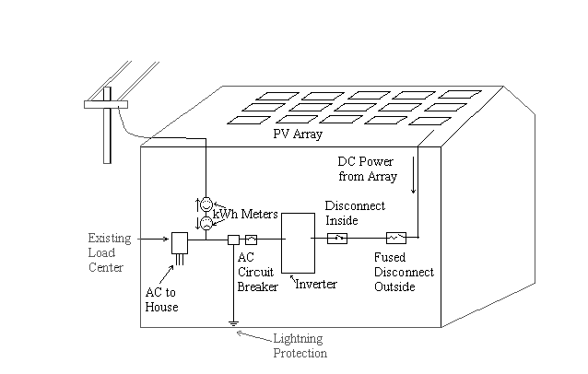Components of a grid tied PV system. On top is the PV array. The direct current from the array goes through fused disconnects and lightning protection before it enters the inverter. The inverter changes the direct current into alternating or AC current. There is an AC circuit breaker and lightning protection before the AC current goes to the house load or back to the utility grid thereby turning the kWh meter backwards. Two kWh meters are shown to indicate that electricity can flow from the utility to the house and from the PV array to the utility. A typical kWh meter will run backwards when electricity flows to the grid.
A photovoltaic (PV) array is a group of photovoltaic modules put together to generate electricity. A PV array may consist of one module to thousands of modules and the output of the array may vary from a few watts to tens of Megawatts depending on the number and output of the modules.
A photovoltaic array produces direct current that is used to power the “load”. This can range from charging a battery in a calculator to powering a communications system to powering a building or city. When a PV array is connected to the utility grid, it must first be connected to an inverter that changes the direct current to alternating current. Most inverters run at about 90% efficiency.
Today’s inverters are very sophisticated and produce very clean power at a stable voltage. By clean power one means that the alternating current is in the form of a sine wave with very little distortion or higher order harmonics. The grid connected inverters are designed to stop the flow of electricity to the utility grid if power from the grid fails. This prevents injury to those who work on the power lines to restore power.
To obtain the most electricity from the solar cell array, inverters contain a module that monitors the voltage and current from the array and the load and makes adjustments to maximize the energy output from the array. This module is called the max power point tracker.
Table 1 contains the voltage and current of a PV module as the load is varied from near a short circuit (zero resistance) to near the open circuit (infinite resistance). When the current voltage (IV) curve is plotted, it is not linear like devices that follow Ohms law but follows a curve as shown in the figure next to the table. While a solar module is similar to a battery, the junction barrier also acts like a diode and the description of the circuit becomes complex.
The short circuit current is proportional to the incident solar radiation while the open circuit voltage is nearly independent of the incident energy. The power from the array is the current times the voltage. The maximum power point is the voltage and current where the maximum power is obtained for a given solar radiation level. Modern inverters contain max power point trackers to keep the solar electric system operating at optimum efficiency.
The solar cell is similar to a battery and as the load varies, the current voltage curve doesn’t follow Ohms law.
Table 1 Sample PV module output
under varying loads and constant
solar radiation.
Voltage  Volts | Current  Milliamps | Power  Watts
0.18 | 888 | 0.16
9.36 | 882 | 8.26
17.85 | 866 | 15.5
25.22 | 823 | 20.8
32.05 | 359 | 11.5
32.88 | 127 | 4.18

Further resources and follow up: There are numerous websites with information on this topic. The University of Oregon's Solar Radiation Monitoring Lab maintains a site at http://solardat.uoregon.edu/ that has solar data, information about solar monitoring, and lists and links to many other sites. A nice supplement to the teaching material above can be found by going to the U of O site and selecting the “PV Performance Calculator-NREL”. At that site select “How Photovoltaics Work” for materials of various interesting kinds.

Useful Web Sites:

http://www.eren.doe.gov/millionroofs/whatispv.html
http://www.sandia.gov/pv/training.htm
http://www.nrel.gov/ncpv/
http://www.fsec.ucf.edu/Ed/index.htm
http://www.nrel.gov/data/pix/searchpix.html
http://www.ascensiontech.com/RTD/ashlandrtd.html
http://www.ascensiontech.com/RTD/pge.html
http://www.ases.org/
http://www.seia.org/main.htm
For further reading:
The Solar Electric House by Steven J. Strong with William G. Scheller, Sustainability Press, Still River, Massachusetts 01467-0143, 1987.
From Space to Earth – The Story of Solar Electricity, John Perlin, aatec publications, Ann Arbor, MI 48107, 1999.

