PV Activity 5: Photocell Output vs. Lamp Distance©

- To investigate the photovoltaic (PV) cell output power dependence on the distance between the PV cell and an incandescent lamp.

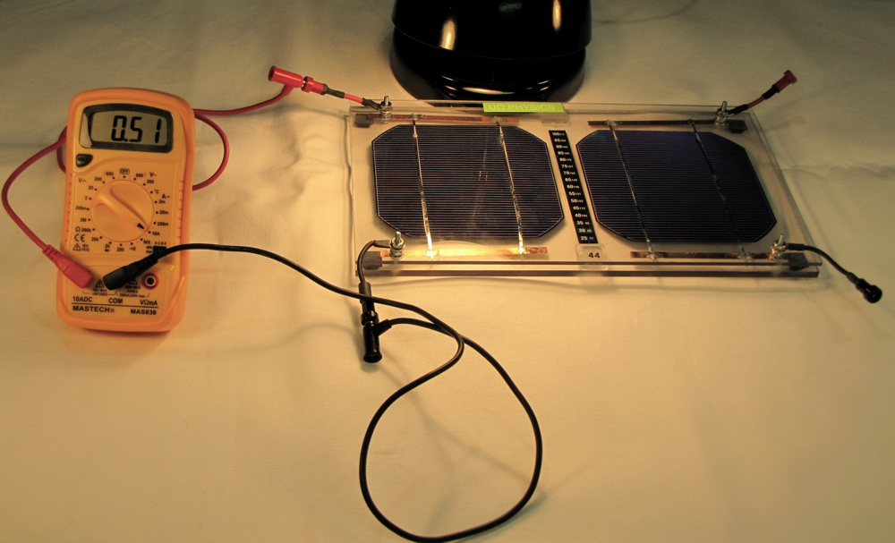
Current meter connected to the PV cell

MATERIALS

- PV Cell Module
- Electrical Leads
- DC ammeter
- DC voltmeter
- 1 Lamp
- Ruler
- Graph Paper

Overview
This experiment measures the current as the distance between the solar cell and the lamp changes. The power generated by the solar cell is calculated and the change in power with respect to the distance is plotted.
Short Circuit Current and PV Cell Power Output
- Connect one Solar Cell in the PV Module to an ammeter as shown in Fig 1 above. The red connector is the + output of the cell. The + output connects to the 10ADC input on the meter. The negative black output from the module connects to the COM input of the meter. Set the meter dial to the 10A setting (See Fig. 5.1). Place the desk lamp as CLOSE AS YOU CAN to the PV cell. Fig. 5.1: Connections to measure short circuit current.
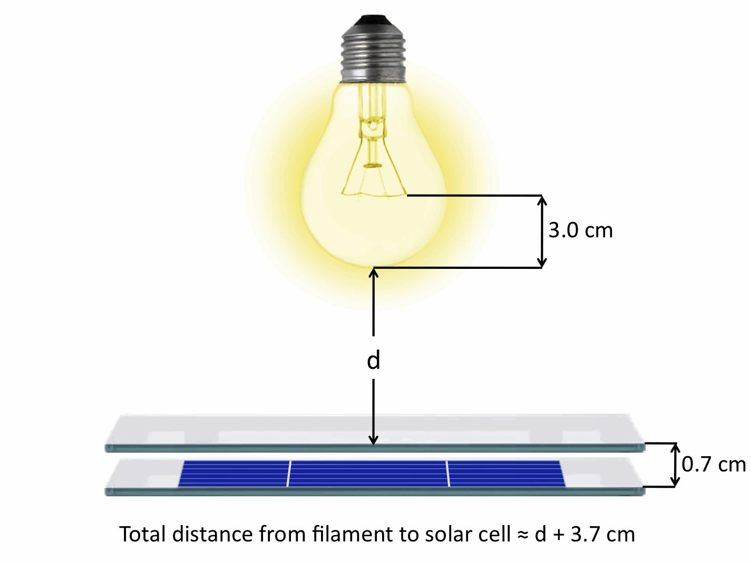
Fig 5.2: Measuring distance between solar cell and light bulb filament.
Measure the distance between the bulb surface and the PV Module. You need to add 3.7cm to your measured distance to have the actual distance between the filament inside the bulb and the solar cell surface located underneath the module’s protective cover. (SEE FIG 5.2) Enter the measured distance and short circuit current measured by the meter in Table 1 below. (If your current reading is zero check your connections and meter settings or ask an instructor for assistance.

- Vary the distance of the lamp to the cell by placing the lamp on blocks or books. Each time, determine the total distance and the output current in Table 5.1.

- We want to examine the actual power output of the cell vs. the actual distance from the lamp filament. Calculate the delivered power (P= I²⁻R ) by squaring the current and multiplying it by the resistance of the current meter which is 0.044.

Table 5.1: Current and Distance
Distance between bulb surface and PV Module (cm) | ACTUAL DISTANCE  (Measured Distance +3.7cm) | Current (Amperes) | Power = I²⁻R  = I²⁽(0.44)

Analysis: Using a computer graphing program or graph paper, plot a graph of Power vs. Actual Distance and see what kind of relationship exists.

What happens to the current when you double the distance between the lamp and the cell? Is the current half as much or is it less than half of what it was?

Result discussion: The shape of the Current vs. Distance graph is a result of how light intensity from a point source diminishes over distance. The power should fall as a 1/r² relation, because the intensity of the light striking the surface decreases as a 1/r² relation. You may not see this exact relation here because we are not dealing with a perfect point light source. The number of charges available IS DEPENDENT on the intensity or brightness of the light, assuming that the voltage is held constant.

The sensitivity of the output current and power with light distance makes it essential to maintain the same light intensity for all future lab measurements. Keeping the distance between the bulb and PV module constant when comparing measurements, or keeping the angle of the PV module and sunlight constant through all measurements will meet this criteria.

Discussion: Write down your comments and what you learned or questions you have after completing Parts I and II. Does the discussion above make sense with your observations and measurements?

