PV Activity 6: Output vs Sun angle©

- To investigate PV cell output dependence on the sun angle

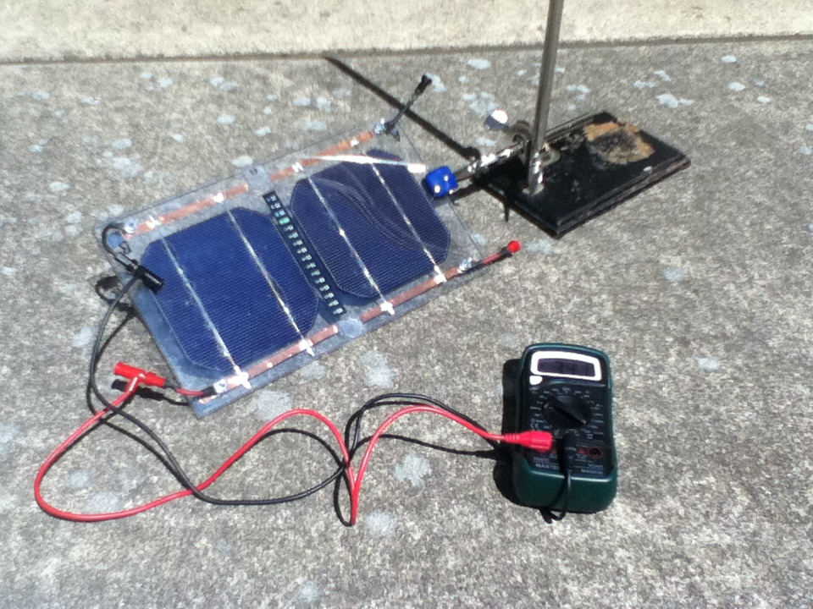

MATERIALS
- PV Cell Module
- Electrical Leads
- DC ammeter
- Protractor
- Set-up stand and burette clamp top hold the module at various angles.
- Sunny Day!

Overview: This experiment requires clear skies for the time the experiment is conducted. Clouds that block the sun significantly change the incident solar radiation and this will affect the experimental results. The idea is to have the panel oriented towards the sun while it is tilted upwards at 15 degree intervals while the current is being monitored and recorded. The results should show that the optimum tilt is when the panel is nearest to perpendicular to the incident sunlight.

Part I: Measuring the Effect of Sun Angle on Current Output

The PV module was set up using a ring stand and a burette clamp most likely found in a Chemistry lab. The angle is varied by rotating the clamp and the angle of the cell was measured relative to the ground with a protractor using an edge of the PV module.

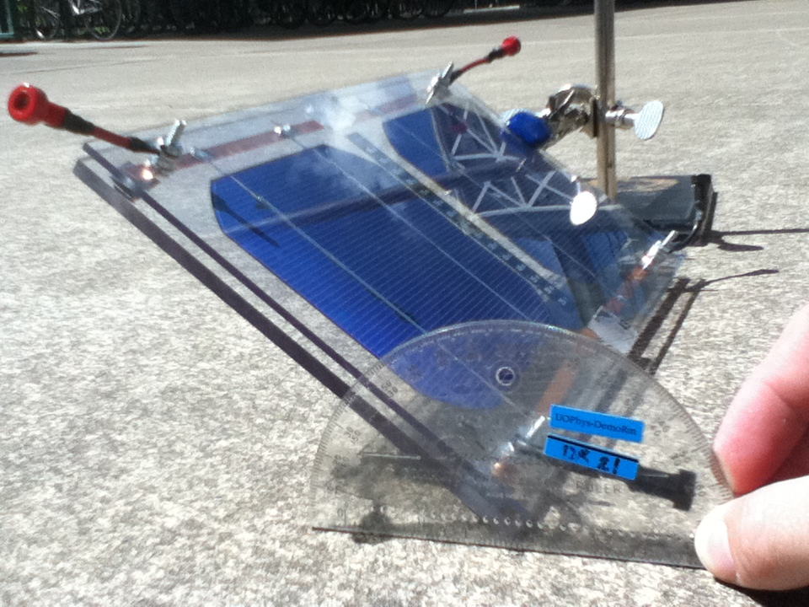
Fig. 6.1: Connecting the amp meter to the Fig. 6.2: Using a protractor to measure the
solar cell. tilt of the cells.

- Connect the cell (or cells) to the amp meter to measure the short circuit current (see Fig. 6.1). Start with the PV module lying flat on the ground and measure the current. Raise the module toward the sun and set it at 15° intervals and record the current generated and tilt (See Fig. 6.2) in data Table 6.1. For the last measurement, face the module away from the sun, obtains a reading of current from the diffuse solar radiation, light from the sky, ground, surrounding buildings, etc.

Table 6.1: Effect of Tilt Angle on Cell Current Location Latitude =
Angle (Degrees) | Current (Amps)
0⁰ Flat on the ground
15⁰
30⁰
45⁰
60⁰
75⁰
90⁰

Module facing away from the Sun (Diffuse)

- Plot a graph of Current vs. Angle. Draw a smooth curve through the data points and answer the following questions.
Questions:

1) At what angle is the current a maximum?

2) How does this angle compare with the latitude of the location?

3) How would this angle change over the seasons?

4) How does the maximum current compare to the current if the solar module is flat on ground? How would this change over the seasons?

5) You can see that light from the sky and surrounding environment also produces current. What percentage of the maximum current is from diffuse radiation?

Discussion:

An Optional Experiment: - Enhanced Reflectance

By placing a highly reflective surface, such as a sheet of aluminum foil between the sun and the module, the amount of ground reflected irradiance can increase significantly. Repeat the initial experiment with the aluminum reflector and compare the results.

Before conducting the experiment, estimate the increase in current. After conducting the experiment, compare the estimate with the actual increase or decrease. Explain the experimental results.

Instructor Notes:

The incident energy on the solar module is equal to the sunlight coming directly from the sun projected onto the surface of the module plus the diffuse radiation from the rest of the sky plus the light reflected from the ground onto the module. The sunlight coming directly from the sun, call direct normal irradiance (DNI) is the largest solar component on a clear day. The direct component on the module surface is the DNI times the cosine of the incident angle. The incident angle is zero when the module is perpendicular to the incoming DNI. The diffuse horizontal irradiance (DHI) is between 10 and 20% of the global horizontal irradiance (GHI) on the horizontal surface.
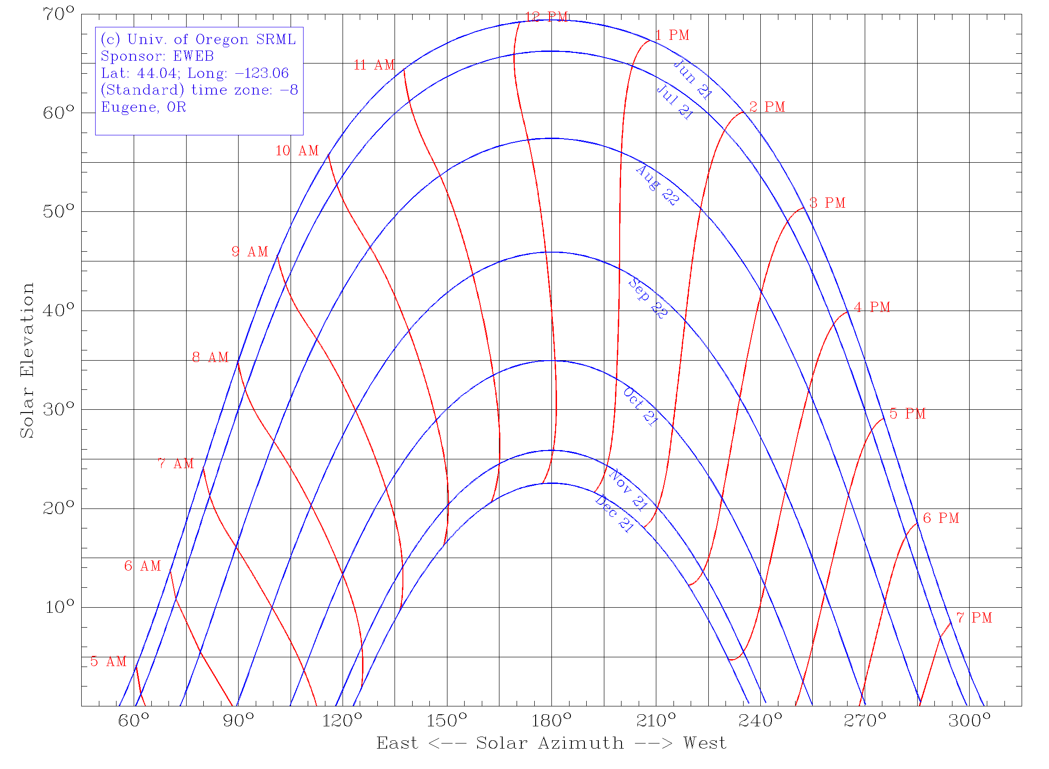

Sun path charts can be obtained from http://solardata.uoregon.edu/SunChartProgram.php. This sun path chart supplies information on the sun’s zenith angle and can be used to better understand the angle the sun is making with the solar panel.
Sample Sun Angle Experiment:
The PV cell was set up in the following arrangement using a ring stand and a clamp. We can change the angle of the cell by simply rotating the clamp in the angle bracket. The angle of the cell was measured relative to the ground with a protractor using an edge of the PV module.

In the following data set, 0° was taken to be the angle of the PV from the ground, with positive angles facing the sun and negative angles facing away from the sun. The cell was tilted in regular increments, moving from facing away from the sun to facing it. Direct sunlight can still reach the surface of the module until the module is tilted 90° away from the sun.
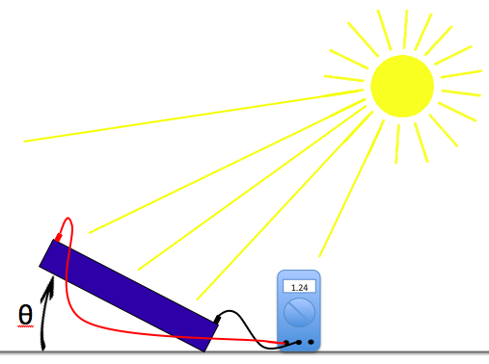 | 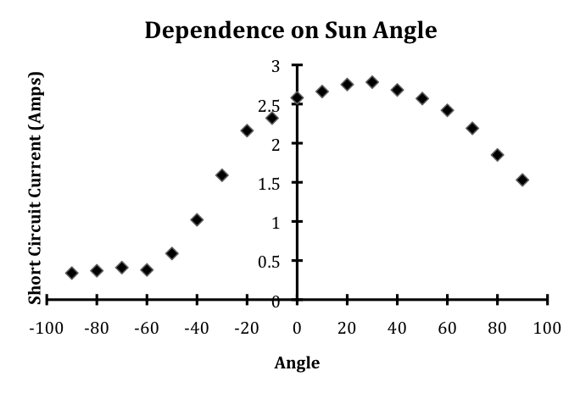

Notice that the current increases as the solar cell is tilted more directly at the sun and reaches a maximum when it is perpendicular to the sun. The baseline that occurs when the cell is facing away from the sun is due to the ambient light that is reflecting off of the ground, surrounding buildings, and the rest of the sky.
Question: The maximum current occurs at angle of about 30°. This data was taken around 3:00 PM in Eugene OR, in the middle of June. Eugene sits at latitude 44°, so, if the sun were directly above the equator, then we would expect a tilt angle of 44° (to the South) to give the maximum current. Why did it occur at 30° instead, an angle less than 44°?

